Equipment Description: CSTR

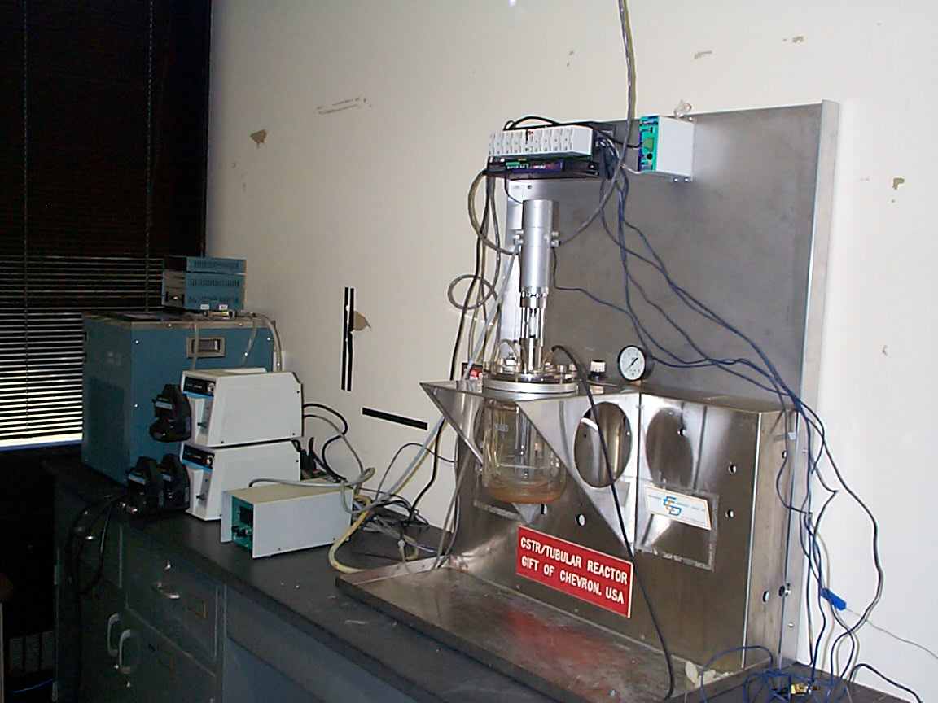
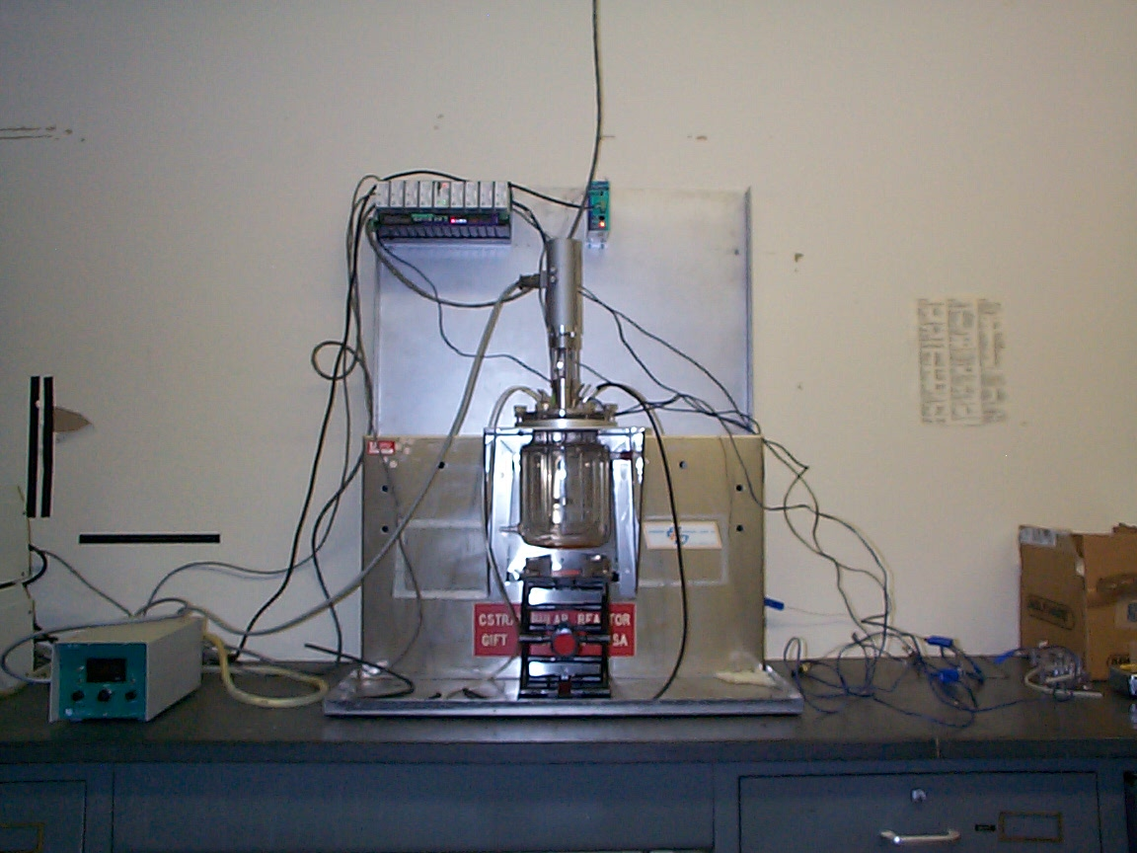
The continuous stirred tank reactor (CSTR) apparatus is located on the south workbench in the Chemical and Fuels Engineering Senior Laboratory located in Room 3520f of the Merrill Engineering Building. Please refer to the attached schematic for the process diagram. A glass reaction volume is surrounded by a hollow space through which a fluid can be circulated so to keep temperature constant.
Figure 1: CSTR system.
Figure 2: CSTR reactor.

Water is the fluid used to keep the reactor temperature constant due to its large heat capacity, availability, and safety. The water bath is connected to a control unit, which contains a heating element. One must simply set the dial to the desired temperature, and water of constant temperature will be circulated throughout the hollow space in the reactor.

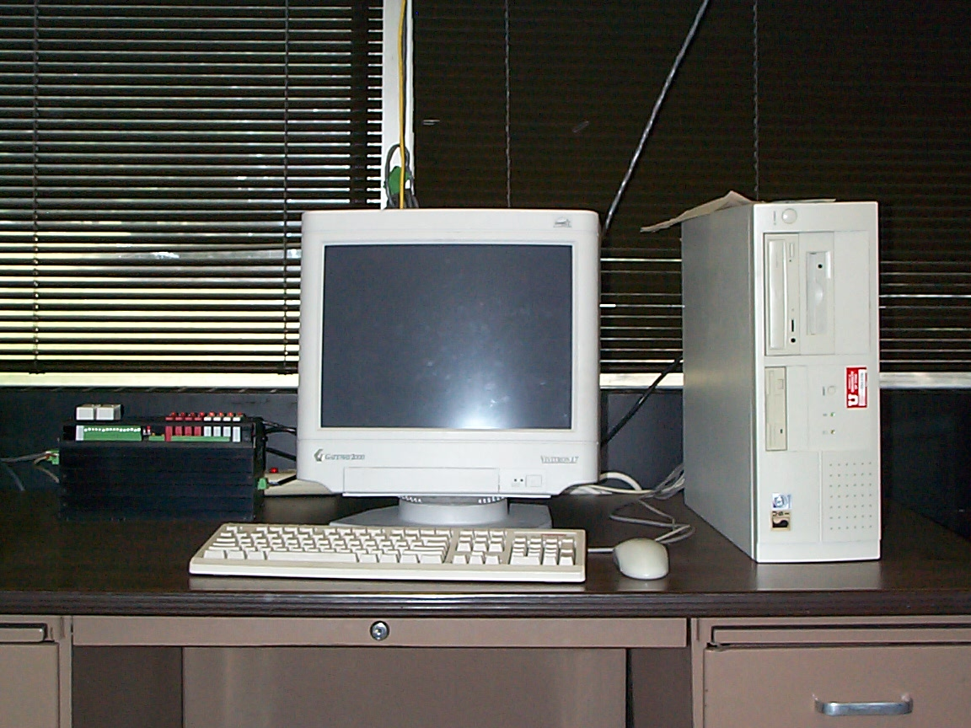
Calibrations should always be performed prior to experimentation. The temperature of a system is critical to how a reaction proceeds. To ensure that the temperature control unit is accurately regulating temperature, the experimenter should perform calibration experiments. Temperatures may be measured using installed thermocouples. An Opto 22 control system is used to control the mixer speed and the pump rates. A PC is available for the control interface.
Figure 3: PC for control interface.

Theoretical Background

The stirred tank reactor may be operated as a steady-state flow type or a batch. However, in most instances, this reactor will be used as a continuous reactor. For an ideal continuous stirred tank reactor (CSTR) the properties of the reaction mixture are the same as those in the exit (product) stream. In addition, the temperature, pH, and composition at which the reaction takes place are the same as the temperature, pH, and composition of any exit stream. Hence, the reaction occurs at a rate corresponding to the product temperature, pH, and composition, and not the values for the feed.
The design equation for a continuous flow reactor is based strictly on the mass balance:
rate of transport of species i into volume element | - | rate of transport of species i out of volume element | + | rate of production or consumption of species i within the volume element | = | rate of accumulation or depletion of species i within the volume element  (1)

Which can be described mathematically as
$Q_{f}{\left(C_{i}\right)}_{f}−Q_{e}{\left(C_{i}\right)}_{e}+r_{i}V=\frac{d\left(C_{i}V\right)}{\text{dt}}$ (2)
where Q_{f} is the volumetric flow rate of the feed stream, Q_{e} is the volumetric flow rate of the effluent stream, (C_{i})_{f} and (C_{i})_{e} are the concentrations of component, i in the feed and effluent streams, respectively. The r_{i} term is the rate of reaction in terms of component i, and V is the working volume in the reactor. Equation (2) is the model that is applied to all continuous reactor systems.
For steady state flow, the accumulation term, $\frac{d\left(C_{i}V\right)}{\text{dt}}$ is zero. Thus Equation (2) can be expressed as
(3)
Also for steady state flow, Q_{f} = Q_{e}. Thus, Equation (3) becomes
(4)

where $\frac{V}{Q}$ is the average residence time of reactants in the reactor volume. This average residence time is commonly referred to as θ.

Unfortunately, ideal reactors do not exist in the laboratories, so adjustments on analysis are necessary. The reaction experiments should not commence until the properties of the reactor are observed. It should not be assumed that perfect mixing occurs, thus it is necessary to characterize the reactor in terms of its drift from ideality. The degree to which a reactor differs from ideality highly depends on the magnitudes of the dead zone volumes and the bypass volumetric flow rate. The dead zone volumes and bypass flow rate can be calculated by analyzing the residence time distribution of particles in the reactor. A response measurement experiment can be used to ascertain a residence-time distribution (RTD) of the constituents in a reactor. Response experiments that are commonly performed involve the measurement of changes in pH, temperature, or the concentration of an inert tracer within the reactor. The time it takes one of these constituents to pass through a reactor is called its residence time, θ. This term is actually the sum of two terms: the elapsed time since the element entered the reactor (its age) and the remaining time it will spend in the reactor (its residual lifetime). The residence-time distribution is defined as the fraction, J(θ) of the effluent stream that has a residence time less than θ. At θ = 0, J = 0, and as θ approaches infinity, J approaches 1 asymptotically.
For a perfectly mixed reactor, it is assumed that the entering fluid is distributed immediately and evenly throughout the reacting mixture. This occurs even on the micro scale where all molecules regardless of age are mixed thoroughly. If the elements of different ages do not mix together at all, then the fluid is termed completely segregated. Segregation can be modeled by lumping all molecules of the same age into theoretical globules. These globules maintain their identity by not exchanging any material with the other globules in the system. Since there is no interchange between the various globules, one can model each globule as a micro scale batch reactor. The time of reaction for each globule is the exact time those molecules spend in the reactor. The distribution of these times is the RTD of the reactor.
Once the RTD has been determined, the information obtained from response experiments can be used to describe the system and its divergence from ideality. A mathematical model based on material balances can be applied to the system to determine the volume of the dead zones and the bypass volumetric flow rate.

