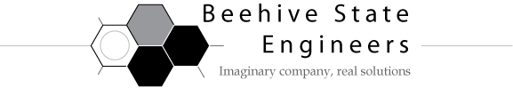

**MEMORANDUM**

**DATE: November 13, 2009**

**TO: Laboratory Group D**

**Brett Christensen, Carolina Oliveros, Michael Beus**

**FROM: Tony Butterfield**

**Engineering Training Supervisor**

**SUBJECT: Liquid Level Control**

Our client is interested in controlling the level of two tanks used as reactors in their lab. The reactors are meant to intermittently treat waste water from a much larger tank, and the reaction is much quicker than the residence time at the maximum possible flow through the reactor. Thus, they simply pump in as much liquid as they can and passively drain the reactors as quickly as possible by gravity into the sewers.

As a remarkably strange coincidence, one of these tanks and its piping match the dimensions of our liquid level control experiment, and to the millimeter. As fortunate as that may seem, the other tank has the same pipe dimensions, but is shaped quite differently (see the figure below).

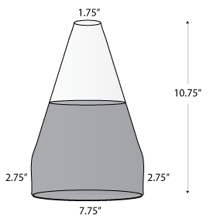

Firstly, please develop a model for the level in both of these tanks as a function of the flow rates. Come to our preliminary meeting with your models so that we may discuss them.

Secondly, use both Ziegler-Nichols and Cohen-Coon methods to determine the tuning parameters these methods recommend for the control for the level of the cylindrical tank at a liquid level around 9”. You may use a PI or PID controller, whichever you think is most appropriate. In your report, comment on the effectiveness and quality of the results from both tuning methods.

Lastly, our client may wish to operate their reactors at various levels. Please determine appropriate tuning parameters at both a liquid level of 2.75” and 9” for both types of tank. Is there significant difference between the most effective controllers at the two heights? If so please make recommendations on how to implement an algorithm capable of handling the range of possible liquid level set points in both reactors.

Thank you and I’ll look forward to meeting with you on or before Wednesday, November 18.